*Select all records and print them to the screen:*

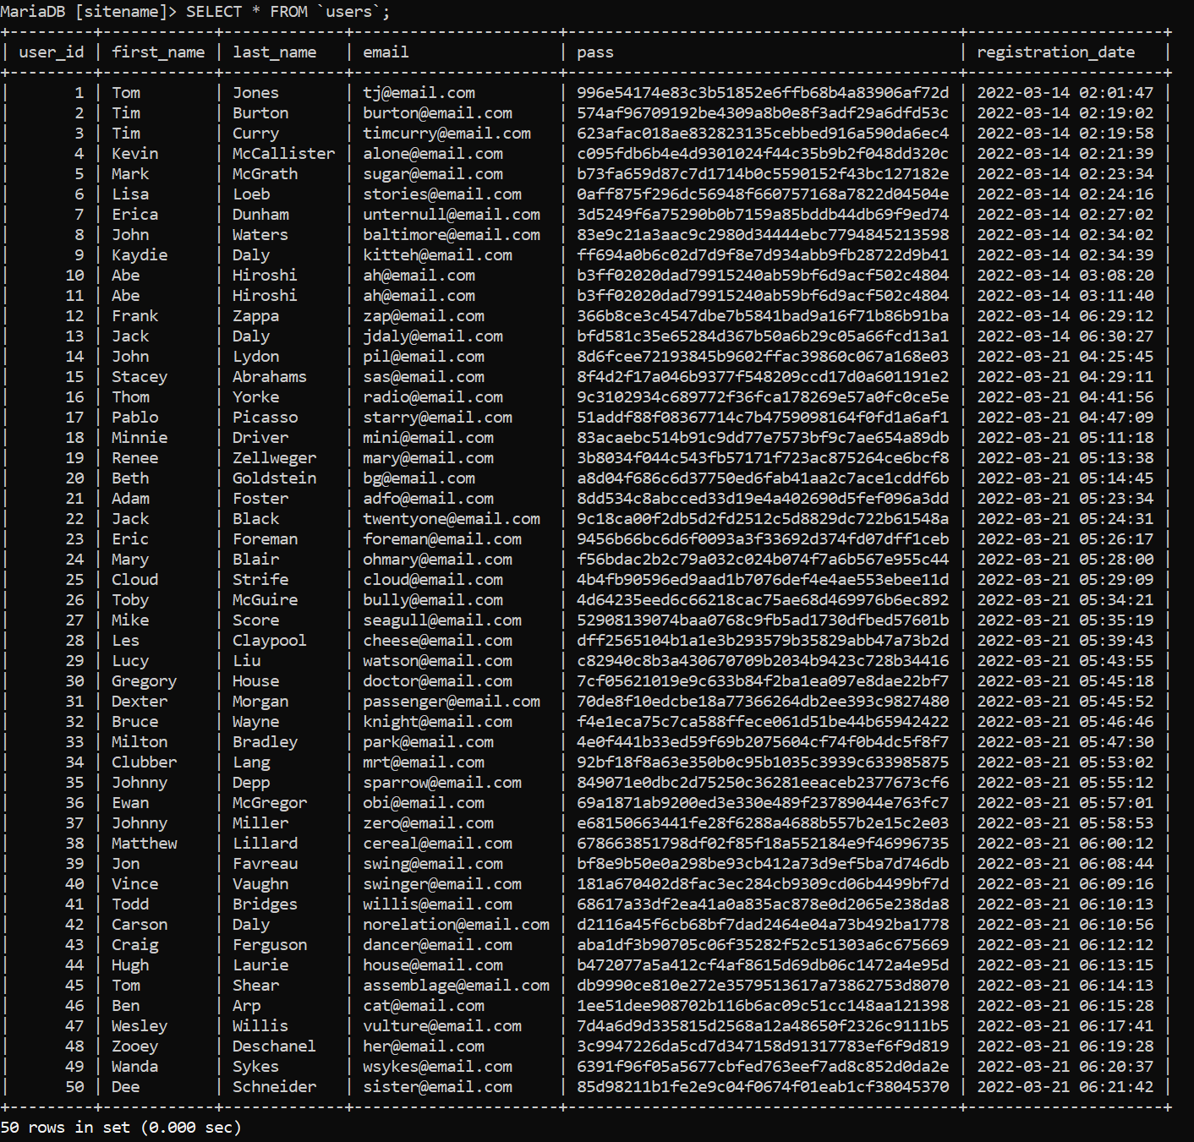

*Select all records, but only print the Last Name and the First Name of the users:*

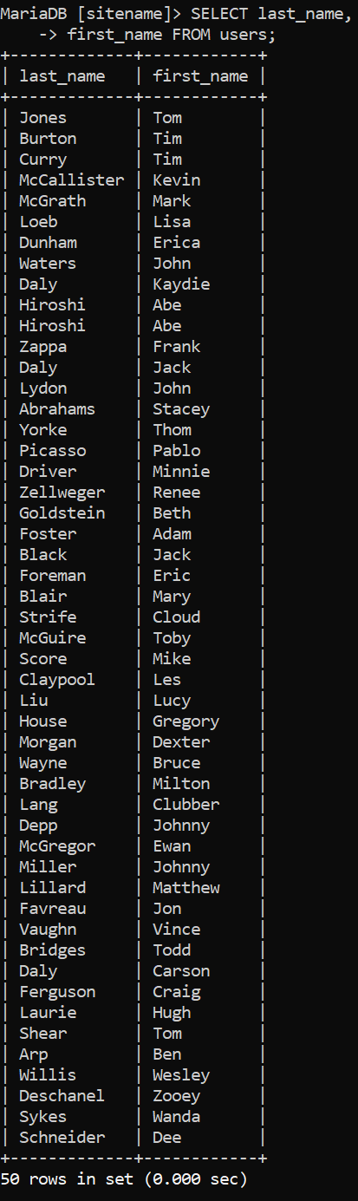

*Select all records from Last Name where the last names are between those that start with a C and those that start with a T. Format the query to read Last Name and then First Name:*

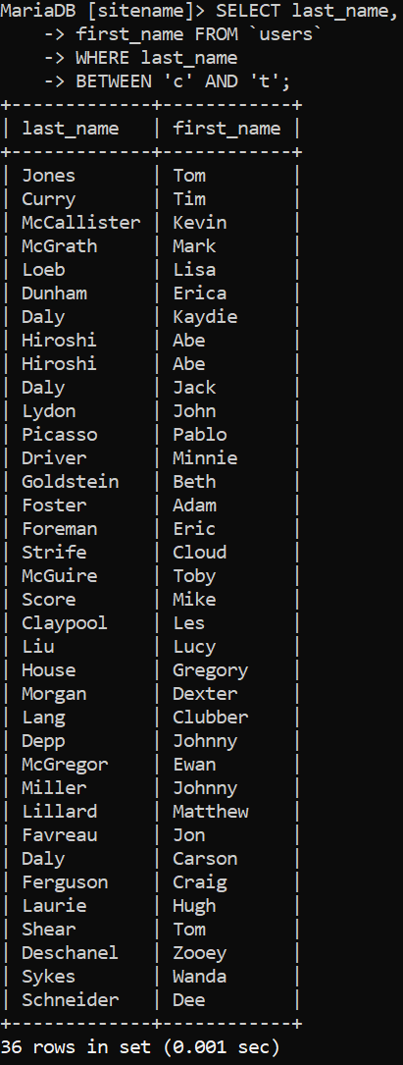

*Select all records from users where the last name is your last name. Show me all columns in this query related to your last name:*

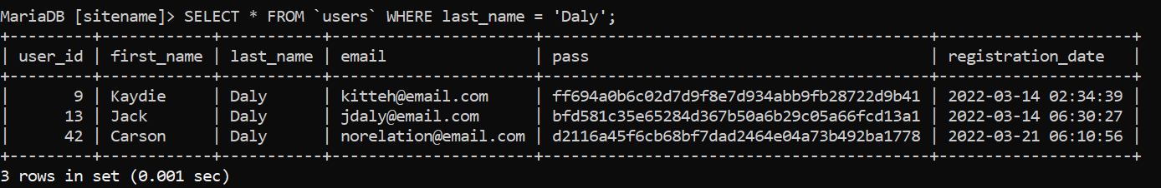

*Select all records where the password is a password in your database. Must use SHA ( ) function to retrieve password:*

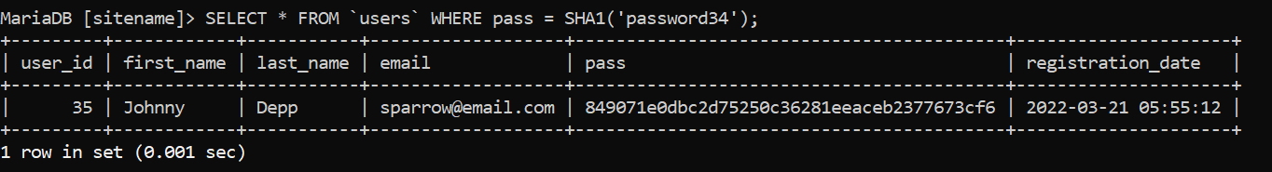

*Select all records where the Last Name starts with an A. (If you don’t have a last name that starts with an A, then use any other letter):*

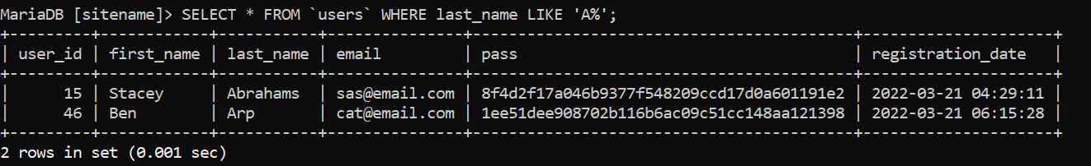

*Select all records, that is not your name, and print them to the screen in descending order:*

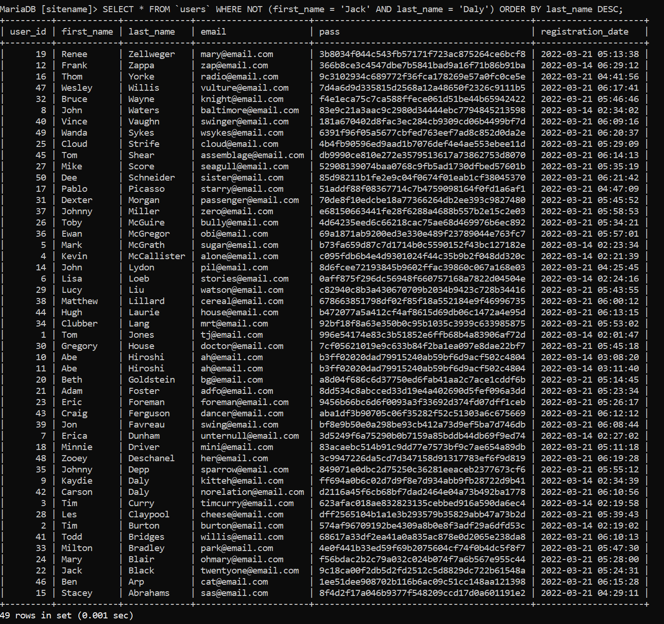

*Select all users in your database and order by registration date in descending order, with a limit of 10 records, to be printed to the screen:*

